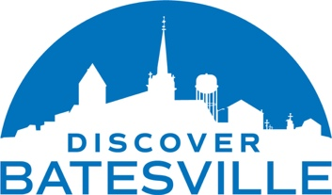
FOR IMMEDIATE RELEASE

City of Batesville Expands its Economic Development Website: Discover Batesville

Discover Batesville set to relaunch in March, receives recognition from AVA Digital Awards for creative excellence in website digital design.

BATESVILLE, Indiana. – March 30, 2023, Discover Batesville has a clear mission: to promote economic vitality, community prosperity, and quality of life for businesses, residents, and visitors. We’re excited to announce that our newly redesigned website helps fulfill the mission, showcasing all that Batesville has to offer. Whether it’s our top-rated schools, excellent healthcare, or through workforce development and training programs, we’re investing in our future and fostering economic growth throughout Batesville, Indiana. The site is scheduled to relaunch on Thursday, March 30, 2023.

“One of our priorities was to make information more easily accessible to both site selectors and the public through demographic data about our city, as well as maps and links to relevant resources,” said Sarah Lamping, Economic Development Director for the City of Batesville. “Also being recognized for the passion and details that went into developing a first-class, yet informative economic and community development website featuring the workings of a robust plan and marketing strategy, is rewarding.”

Prior to relaunching, the website was submitted for consideration in the Website Design/Government category with the AVA Digital Awards, an international competition that recognizes excellence by creative professionals responsible for the planning, concept, direction, design, and production of digital communication. The newly redesigned website received recognition, 2023 Honorable Mention.

The Batesville Marketing Coalition: comprised of the Economic and Community Development Directors from the City of Batesville, representatives from the Economic Development Commission, Batesville Area Chamber of Commerce, and Batesville Main Street launched www.DiscoverBatesville.com in 2022. They are very excited about the new expanded site, featuring over 80 user-friendly and informative pages with vibrant photography to attract quality businesses, investors, residents, and visitors.

For more information, additional details, or to join the e-newsletter, visit www.DiscoverBatesville.com or contact Sarah Lamping at slamping@batesville.in.gov or (812) 933-6113.
###

