BATESVILLE PARKS DEPARTMENT
MEMORIAL BRICKS
Batesville’s Park department would like to give the community the opportunity to purchase an engraved 4”x8” brick paver located in Veterans Park. This park is located on the corner of South St and Depot St. behind Harmeyer’s Market. A beautiful flagpole was donated by the VFW Post 3183, the VFW ladies and men’s auxiliary. The corner of the park was landscaped, along with a concrete accessible area, with 216 pavers.
The money raised from the engraved bricks will be used for park improvements at this park. Money already raised funded the much-needed safety surfacing under the playground equipment. The current needs of the park are new trees, as many have been lost recently.
The 4”x8” engraved bricks can be purchased for a donation of $50.00. There are red bricks that will be reserved to purchase for any veteran, living or deceased, active member, or anyone who has served this country. The remaining bricks can be engraved to commemorate someone in your family, a parent, a grand-parent, a loved one, your family, a special group or special event. Businesses, churches and civic groups are encouraged to participate as well. Please help support the park system and the South St. Park.
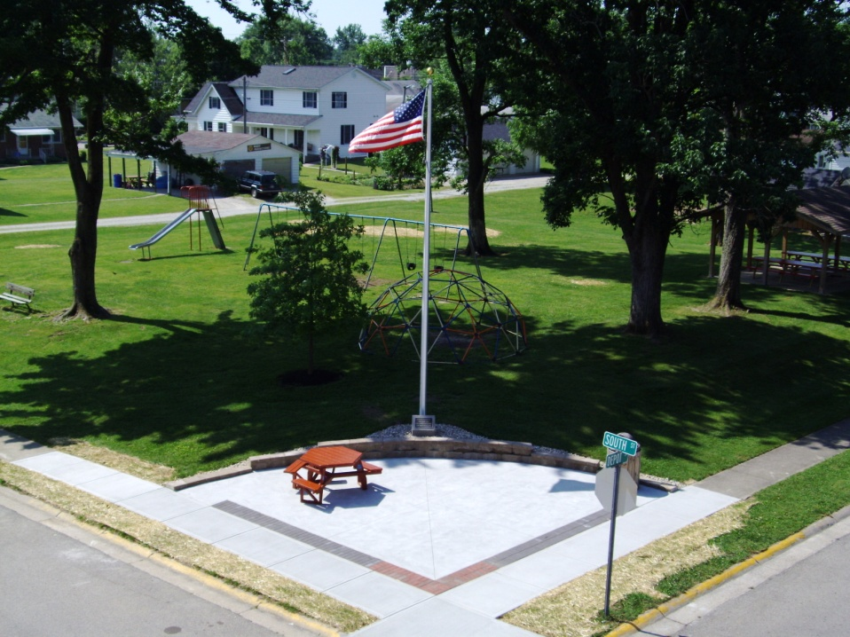
ORDER FORMS MAY BE PICKED UP AT THE MEMORIAL BUILDING
AND RETURNED TO BATESVILLE PARKS
716 SOUTH MULBERRY ST. BATESVILLE, IN 47006

3 different options will be available for the bricks.
Option #1 1 ½” characters one line 8 characters max
Option #2 1” characters two lines 10 characters per line
Option #3 ¾” characters three lines 16 characters per line
Please select the option you want and the message you wish to appear on your brick
- Use only one character(letter, space, etc) per space
- Please print exactly as you wish to have it appear on the brick
- Information will be centered on your brick
- If you would like a certain brick, or area for your brick, please specify and we will try to accommodate(for example in a corner, a red brick(military), next to someone else’s, etc)
PLEASE CHOOSE ONLY ONE OPTION
___ Option #1
1 ½ “ characters 1 line-8characters per line
___ ___ ___ ___ ___ ___ ___ ___
________________________________________________________________
___ Option #2
1” characters 2 lines-10 characters per line
___ ___ ___ ___ ___ ___ ___ ___ ___ ___
___ ___ ___ ___ ___ ___ ___ ___ ___ ___
___________________________________________________________________
___ Option #3
¾” characters 3 lines-16 characters per line
__ __ __ __ __ __ __ __ __ __ __ __ __ __ __ __
__ __ __ __ __ __ __ __ __ __ __ __ __ __ __ __
__ __ __ __ __ __ __ __ __ __ __ __ __ __ __ __

