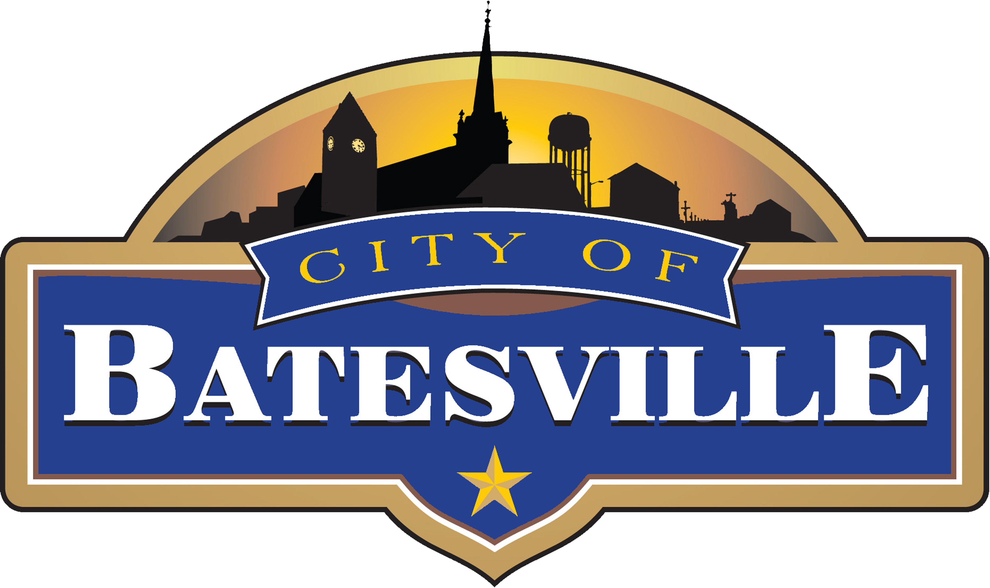
Indiana
132 SOUTH MAIN STREET | BATESVILLE, INDIANA 47006
812.933.6100 | FAX 812.933.0698 | www.batesvilleindiana.us
Est. 1852

Press Release

Duke Energy awards more than $125,000 in grants to support economic development in Indiana.

BATESVILLE, Ind., May 2, 2023 – Duke Energy Corporation is awarding more than $125,000 in grants to 26 local and regional economic development organizations to spur new jobs and investment in Indiana communities. The grants are through Duke Energy’s Partnership Program, which funds marketing and strategic efforts to grow cities and towns.
“We believe that when our communities thrive, we thrive,” said Erin Schneider, managing director of Midwest economic development for Duke Energy. “That’s why we work hand in hand with local and regional economic development organizations to bring new jobs and capital investment to the communities we serve, and our Partnership Program is one example of that.”
Grant dollars are used to support marketing campaigns and promotional materials, website development and updates, conference and tradeshow registrations and continuing education.
Local Economic Development organizations receiving awards were:
City of Batesville, Economic Development received a $5,000 award.
The I-74 Business Corridor received a $5,000 award.
Since the Partnership Program was established in 2017, Duke Energy has contributed more than $700,000 in grant funding to organizations that are helping create vibrant economies in Indiana.
To qualify for program consideration, each applicant submitted a plan that would have a direct impact on their community’s economic growth. These awards help local and regional economic development organizations fund marketing and strategic efforts in Duke Energy News Release to the communities they serve. Amounts varied depending on the size and scope of the project.
To read the full news release visit: https://news.duke-energy.com/releases/duke-energy-awards-more-than-125-000-in-grants-to-support-economic-development-in-indiana

###

