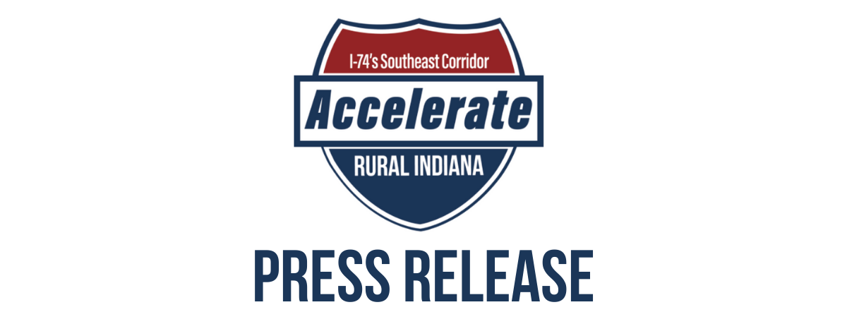
Officials Gather to Celebrate Impact of $20 Million READI Award at Accelerate Rural Indiana Regional Celebration
Batesville, IN — on May 4th, Accelerate Rural Indiana (ARI) was joined by state and local elected officials and representatives from the Indiana Economic Development Corporation to celebrate the region’s early success implementing their $20 million READI award. The region awarded $14 million of ceremonial READI funding checks to 12 projects across the region, with another $6 million in the pipeline.
"Congratulations to ARI and all of the counties in this district for receiving the highest per-capita READI award in the state," said Kurt Fullbeck, vice president of development strategic at the Indiana Economic Development Corporation. "The work ARI is doing is proof that the READI program has been and will continue to be transformative for Hoosier communities. I look forward to seeing further investment flow into this region."
ARI was awarded $20 million of Regional Economic Acceleration and Development Initiative (READI) funding, the highest per capita READI award in the state. In total, the region’s READI project portfolio is expected to attract nearly $500 million of public and private investment to the region by 2026.
“The impact of this investment in the ARI Region will be transformational,” noted Mayor Joshua Marsh of Greensburg during the celebration. “The region’s READI projects are expected to bring an additional 300 single-family homes, 300 multi-family housing units, 170 new jobs, 260 additional childcare seats, five new parks and trails, and three new tourism destinations which will attract over 170,000 annual visitors to the region.”
Two of ARI’s READI projects have already been completed and are ready for regional residents to enjoy with the warming weather. Pirate Park in Greensburg was completed in October 2022 and a Skate Park in Batesville was completed in April 2023.
In addition to celebrating projects, ARI also announced the formation of the Accelerate Rural Indiana Regional Development Authority. The RDA was formed pursuant to Indiana Code 36-7.6, which allows two or more adjacent counties to form an RDA to develop and fund regionally significant projects. The ARI RDA will be governed by a Development Board of five representatives from the ARI region.
The ARI RDA Development Board held its first meeting at Greensburg’s City Hall on April 14th, 2023. HEA 1001, the State’s biannual budget, added an additional $500 million for second round of READI funding. The ARI region hopes to leverage its success with READI thus far and the RDA to secure READI 2.0 funding.
The informal coalition of Batesville, Greensburg, Rushville and Shelbyville along with Decatur, Rush and Shelby counties was formed in 2021.
About READI
Launched by Gov. Holcomb and led by the Indiana Economic Development Corporation (IEDC), READI encourages regional collaboration and data-driven, long-term planning that will attract and retain talent in Indiana. The $500 million READI fund was passed by legislation during the 2021 session and was divided among 17 regions. Through READI, 17 regions across the state that represent all 92 counties are moving forward with projects and programs designed to enhance Indiana’s regions for current and future generations of Hoosiers. Collectively, the state’s $500 million investment is expected to yield an additional $9.86 billion public, private and nonprofit dollars invested (19.72:1 investment leverage ratio) in enhancing Indiana’s quality of life, quality of place and quality of opportunity.
###
Rushville & Rush County Check Presentation
Shelbyville & Shelby County Check Presentation
Greensburg & Decatur County Check Presentation
Batesville Check Presentation
Media contact
Mason Gordon
765-561-9870
mgordon@hwcengineering.com

